Below are instructions for installing python and gitbash. You can use command prompt (cmd) as well and there are instructions for that, but since I am on a Mac, gitbash will allow for everyone to use the same commands. If I only include one set of instructions, they should work for gitbash and cmd. All commands You need to run are highlighted, and anywhere you see <something> that means you need to replace it with the thing described between the <> and remove the <>.

1. Install gitbash: <https://git-scm.com/downloads>

Installing Python

1. Download Python
   1. All versions of Python can be found here: <https://www.python.org/downloads/>
   2. Make sure to choose the correct executable (x86-64 = 64 bit)
   3. DO NOT install the latest version of python. It is always best to use a bit older one because it takes the maintainers of libraries time to make them compatible with the latest versions. I would not select higher than python 3.10
2. Run the installer
   1. Right-click on the installer and click Run as administrator
   2. Select Add Python to PATH
   3. 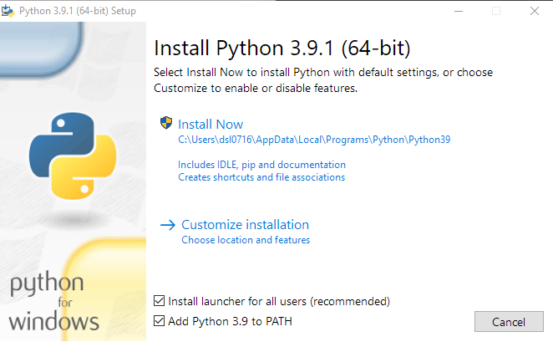
   4. Click Customize installation
   5. 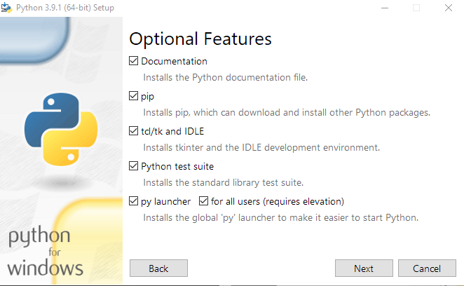
   6. Install to C: drive or Program Files or Program Data
   7. Make sure to check Add Python to environment variables
   8. 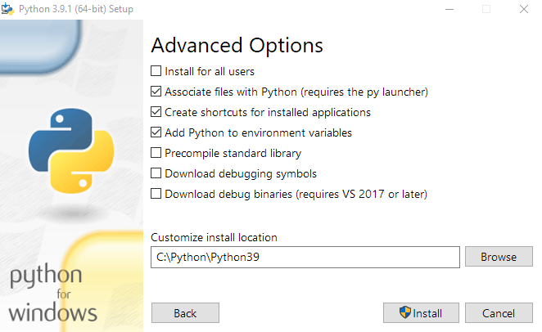
3. Validate install
   1. Open command prompt (cmd) or git bash and type python
   2. 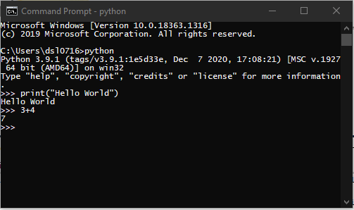
4. Upgrade pip and Install jupyter notebooks
   1. Upgrade pip by typing python -m pip install -U pip
   2. 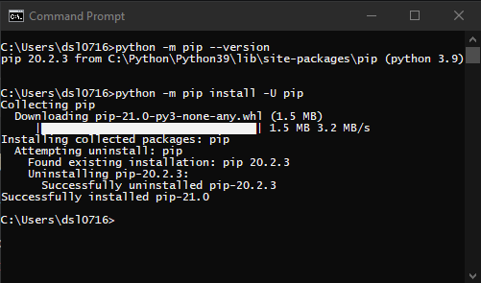
   3. Type pip install notebook
   4. 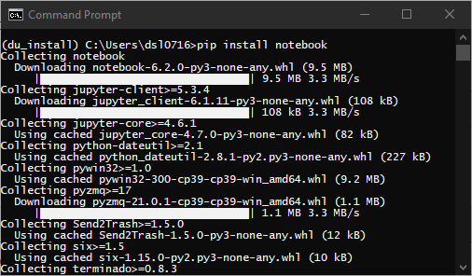
   5. Launch notebook by typing jupyter notebook
   6. 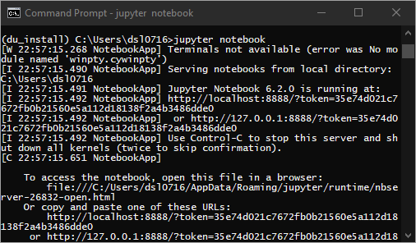
   7. You should now have a notebook that you can write code in! Try the below: 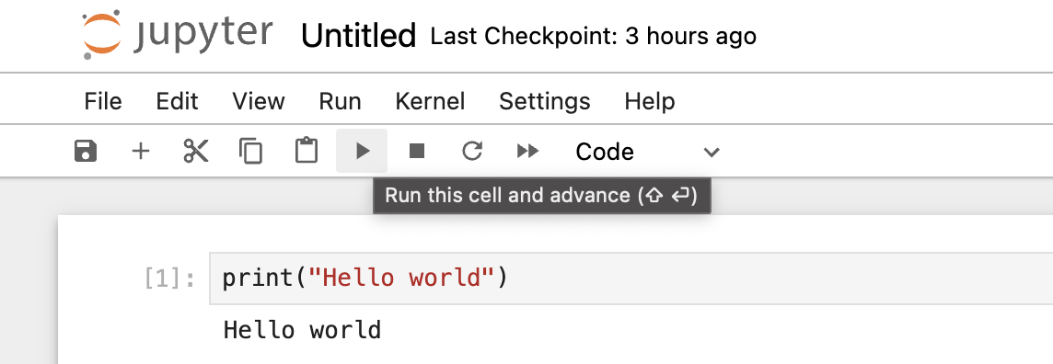
5. Create virtual environment
   1. Virtualenv is a tool to create isolated Python environments. Virtualenv creates a folder which contains all the necessary executables to use the packages that a Python project would need. It is helpful as you get more advanced and are using libraries on your machine where the versions might conflict with each other.
   2. In command prompt or git bash type pip install virtualenv
   3. 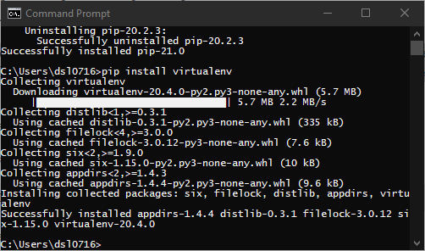
   4. Navigate to wherever you would like to install this environment in command prompt
   5. Create the virtual environment by typing virtualenv <name of environment>
   6. 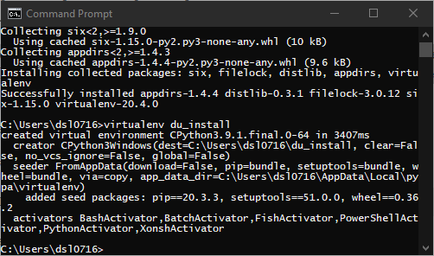
   7. Activate the environment
      1. Command Prompt:
         1. Type <name of virtual environment>\Scripts\activate.bat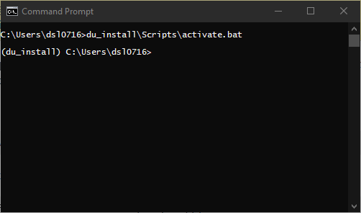
      2. Git Bash
         1. Type source <name of virtual environment>/Scripts/activate
         2. 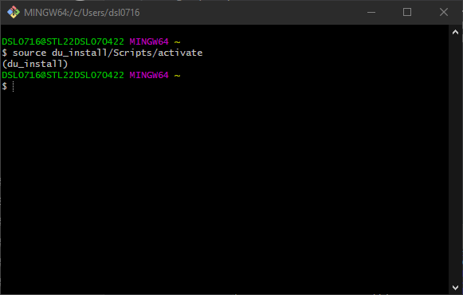

Optional (but helpful) installs:

* [VS Code](https://code.visualstudio.com/) - I use VS code most of the time at work. It may be more difficult to set up jupyter notebooks to work correctly within VS Code in the beginning, but it is commonly what professional engineers/developers use. <https://code.visualstudio.com/>